**Groovy Project**

**If Statement**

Example 1

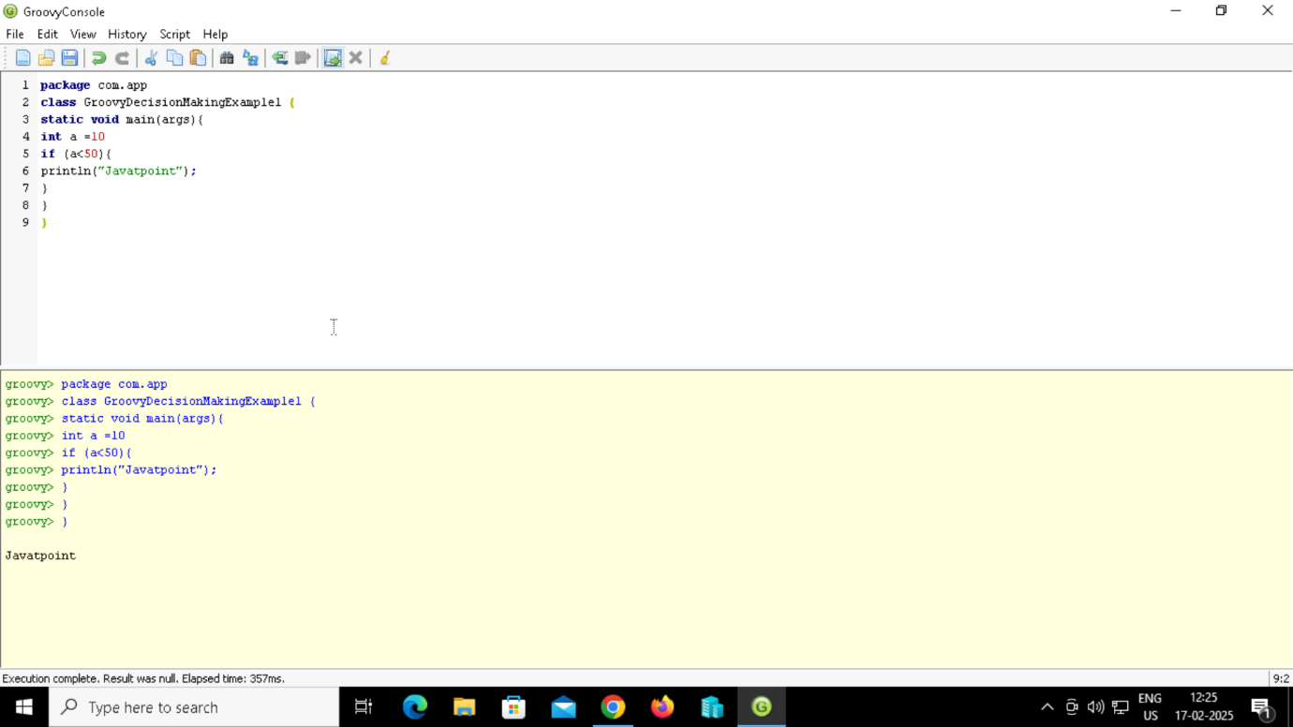

Example 2

**If else Statement**

Example 3

Example 4

**Nested If Statement**

Example 5

**Switch Statement**

Example 6

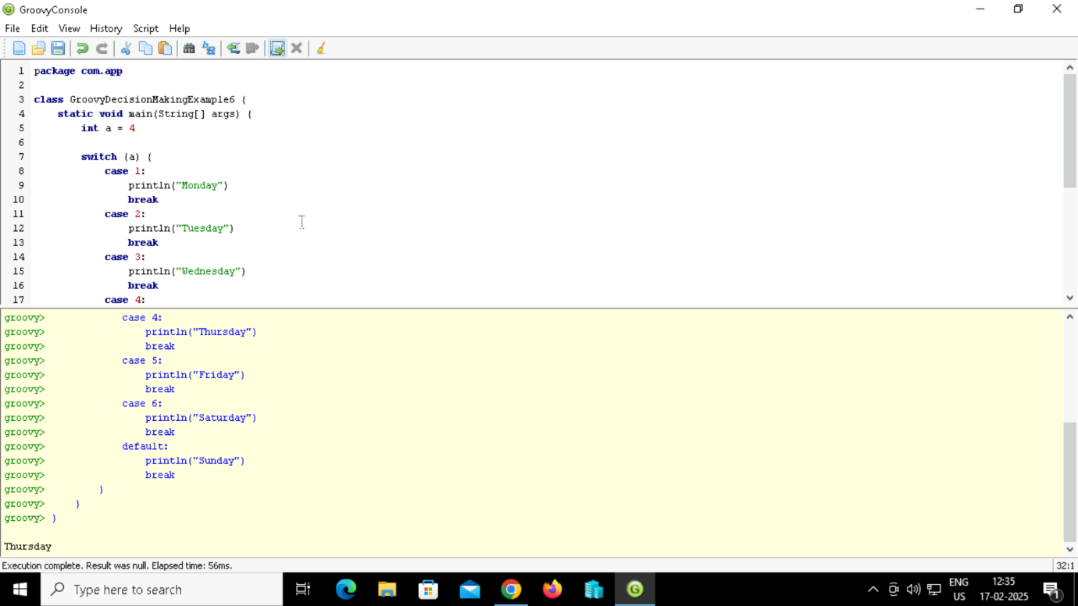

**Single-quoted string**

Example 1

**Double-quoted string**

Example 2

Example 3

**Triple -single-quoted string**

Example 4

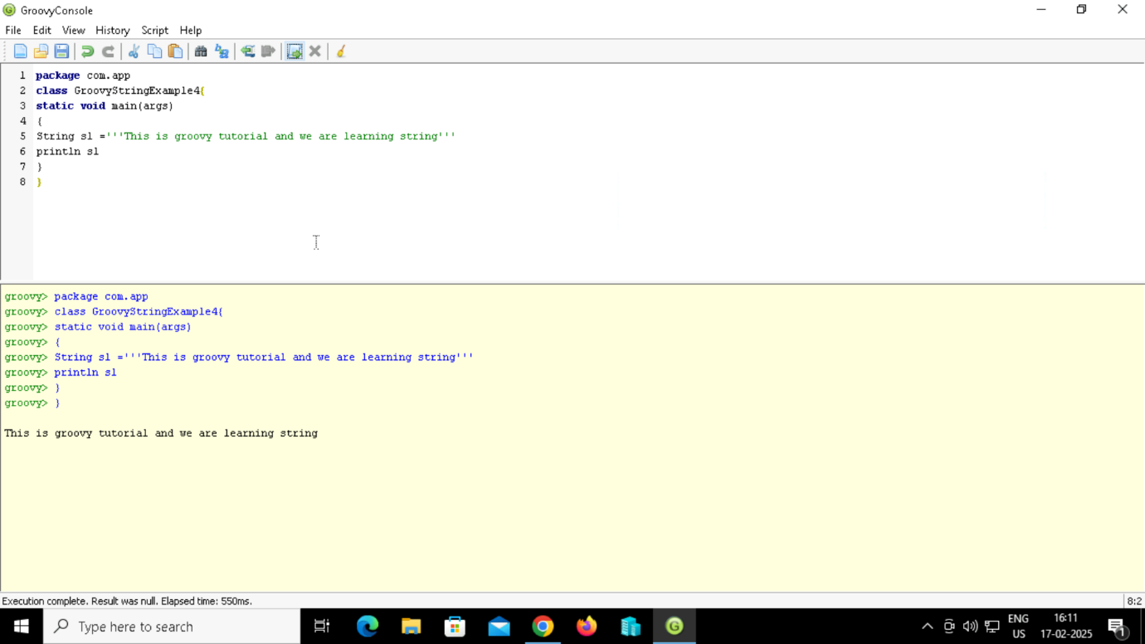

Example 5

**Triple-double-quoted string**

Example 6

Example 7

Example 8

**Slashy string**

Example 9

Example 10

Example 11

**Dollar slashy string**

Example 12

Example 13

Example 14

**Groovy Project**

**5. Web Scraping with Groovy & Jsoup**

**Description:**  
Build a Groovy script that scrapes data from a website and saves it in a CSV file.

**Solution:**

* Use Jsoup to fetch and parse HTML content.
* Extract required elements using CSS selectors.
* Write the extracted data to a CSV file.

**Tech Stack:** Groovy, Jsoup, CSV Parsing  
**Use Case:** Data Scraping, Automation

**Output:**

**1. Groovy Script for Log File Analysis**

**Description:**  
Parse and analyze server log files to extract useful insights like error counts, request trends, and response times.

**Solution:**

* Read a log file line by line.
* Use regex to extract timestamp, status codes, and messages.
* Aggregate and summarize the data.
* Generate a report.

**Tech Stack:** Groovy, Regex, File I/O  
**Use Case:** DevOps, System Monitoring

**Output:**

